ME 351: DESIGN OF MACHINE ELEMENTS

**HELICOPTER GEAR-BOX**

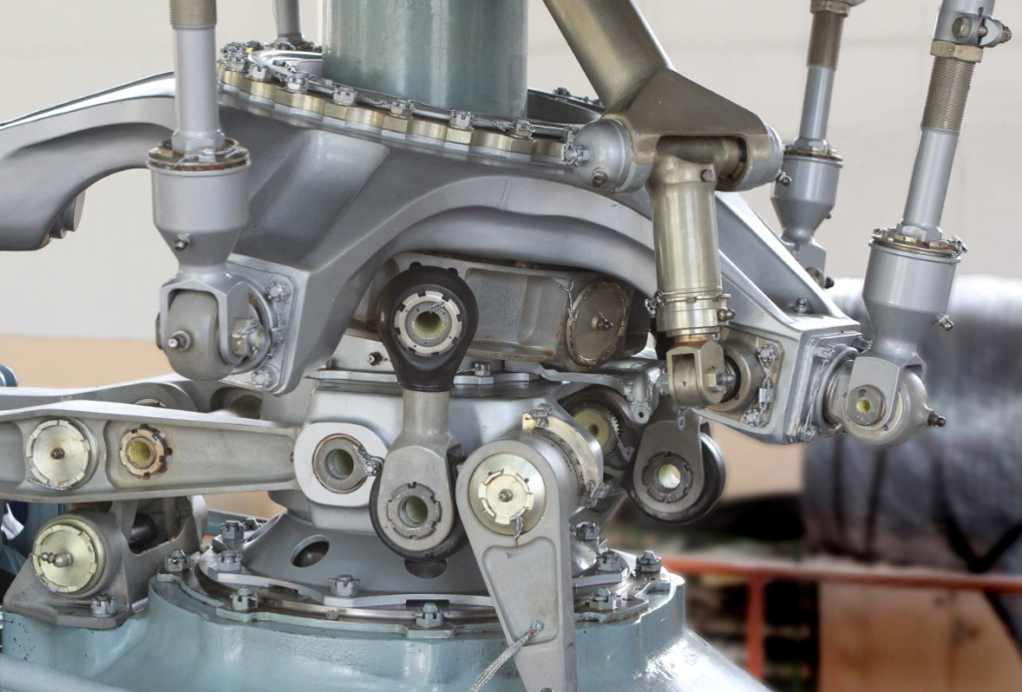

PRESENTED BY:

AVINASH KUMAR 150169

AYUSH SINGH 150177

BHANUPRATAP NIRANJAN 150182

ATUL BIMBRAHW 150162

**Under the guidance of Prof. Venkitanarayanan**



Department of Mechanical Engineering

Indian Institute of Technology Kanpur

**MACHINE ELEMENTS, MOUNTING AND PURPOSE:**

G**ears** serve to reduce or increase speed, change the direction of drive, and split or combine torque paths in a drive system. A designer has several different types of gears in order to best achieve the intended function. **Spur, helical, and planetary gears** transmit torque along a parallel axis while **bevel, worm, and face gears** transmit torque along intersecting axis. For non-parallel axis gears **crossed helicals or hypoids** are used . For helicopter transmissions, the nonparallel axis gears are not normally used because their efficiency “decreases rapidly as the helix angle increases.” Worm gears are also inefficient.

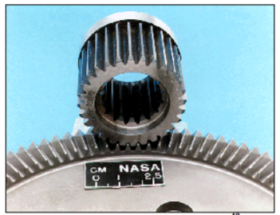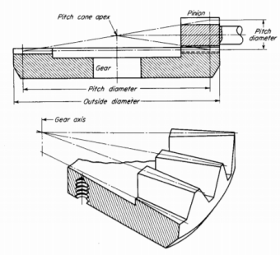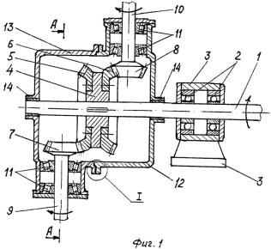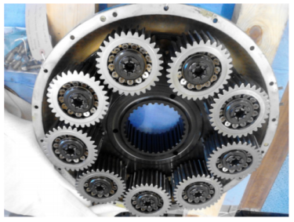

The transmission system of a helicopter gearbox is connected to two **shafts**, one from each of the two free turbines engines, which drive the main and tail rotors. The main rotor gearbox consists of two sections, the main module, which reduces the input shaft speed to one-tenth. This section has two parallel gear stages. This combined drive provides power to the tail rotor drive shaft and the bevel gear. The bevel gear reduces the rotational speed of the input drive and changes the direction of the transmission to drive the **epicyclic reduction gearbox module**. The second section is the epicyclic reduction gearbox module which is located on top of the main module. This reduces the rotational speed to about one-tenth which drives the main rotor. This module consists of two epicyclic gears stage, the first stage contains 8 planets gears and second stage with 9 planets gears.

The epicyclic module planet gears are designed as a complete gear and **bearing** assembly. The outer race of the bearing and the gear wheel are a single component, with the bearing rollers running directly on the inner circumference of the gear. Each **planet gear** is ‘self-aligning’ by the use of spherical inner and outer races and barrel shaped bearing rollers.

**STRESS CONCENTRATION:**

**Gears:**

The stress distribution at the contacting surface is shown for different gear sets.It can be seen that the maximum contact stress decreases with increase in helix angle for a constant friction coefficient.

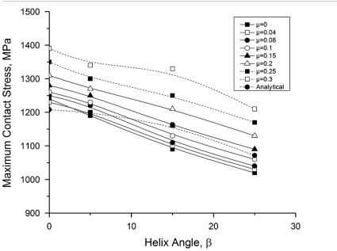

Below are the figures for obtained from test results giving the stress concentration variation.

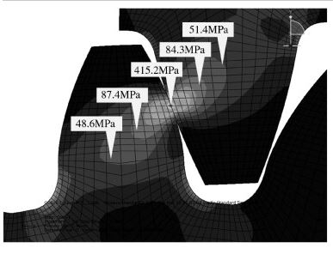 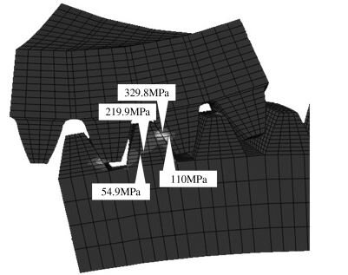

For Spur Gears                                                    For Helical Gears

**Bearings:**

Below is a experimental analysis which determined the stress concentrations at different locations in a bearing

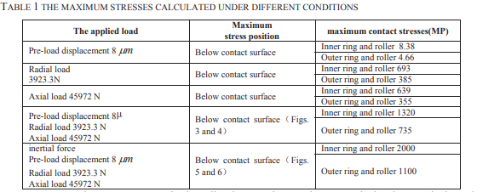

In this particular case the contact stresses in the roller, inner and outer rings are calculated under considering the pre-load, radial load, axial load respectively considering both the external applied loads and the inertia force. From the table we infer that the contact stress produced by the pre-load is small while the stress by the radial load is larger than the axial load. The contact stresses produced in the roller, inner and outer rings changes periodically when a rolling bearing works.

**Shafts:**

Assuming a solid shaft with round cross section.The fluctuating stresses due to bending and torsion are  :

IMG_260

The von Mises maximum stress for static failure is calculated as:

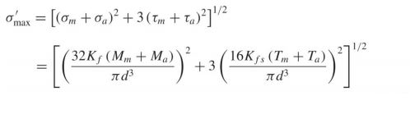

Typically when we have filleted shafts we observe the maximum stress concentration at the fillet and thus we introduce a factor Kt called as Stress concentration Factor.

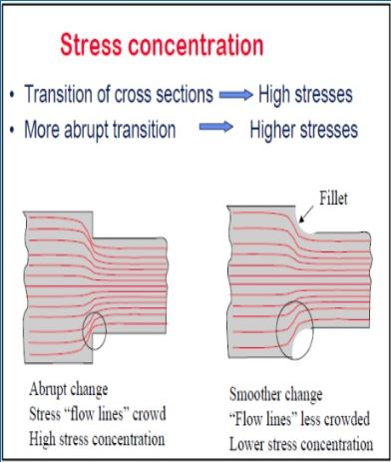

**TYPES OF LOADING:**

**Gears:**

In the helicopter gear box, mostly Bevel, Helical and Spur gears are used and combination of them are called ring gear and sun gear. Tangential, radial and axial forces are generated on the gears due to loads and because of these loads both bending stresses and contact stresses arise. Tangential forces cause the bending stress and contact between the teeth of meshing gears give rise to contact stresses.

Bending stresses which are generated through tangential forces are variable in nature and give rise to fluctuating stresses which have nearly zero mean fluctuating stress. Since one or more than one gear tooth are in contact, contact stress are constant.

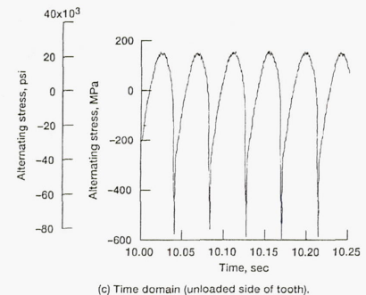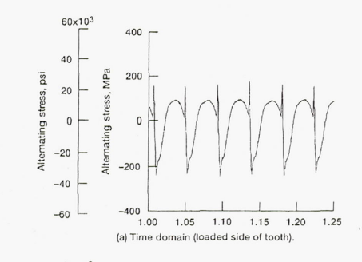

**Bearings:**

The bearings are used to support and shafts and to transfer loads. In the Helicopter gear box, mostly rolling elements bearing are used because of the ability to sustain thrust load which is transferred through gears to shafts. Deep groove ball bearing, tapered roller bearing and thrust bearings are preferred.

This axial load is static but the load on the ball of the bearings fluctuate due to rotation of the inner case. At the time of the loading, balls which are at the top, do not support the load while the balls at bottom do. So, load is both static and fluctuating on the bearings.

**Shafts:**

Shafts carry loads from gears and transfer them to bearings. Some of the loads are static and some are fluctuating. Since the bending stresses caused by weight of the gears are fluctuating because of shaft’s rotation.

**MODES OF FAILURE:**

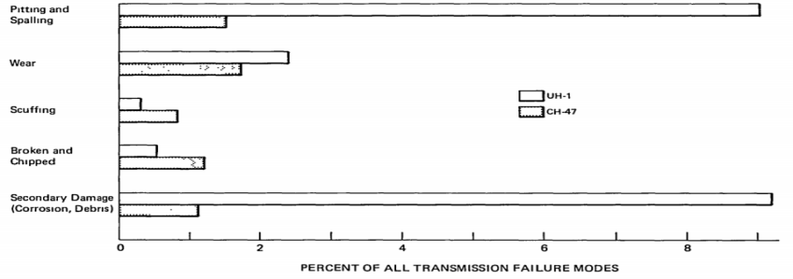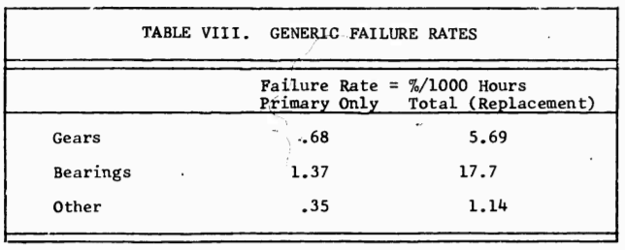

**Gear failure:**

1. **Tooth bending fatigue failure:** It is recognized as a mode of failure which is design sensitive. For unidirectional bending, the gear tooth rotates through a mesh from a zero stress condition to a maximum stress condition and back again to a zero stress condition on each revolution. The vibratory stress is half of the maximum and the base of the tooth is the critical area for bending.

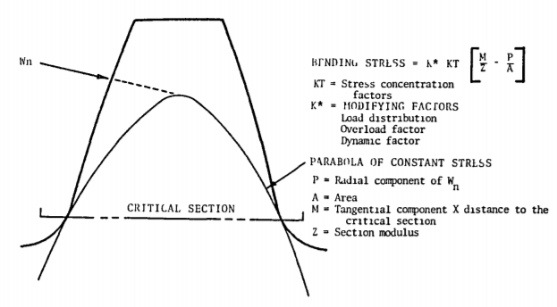

1. **Pitting:** It is caused by high Hertzian contact stress on pinions which normally progresses in fatigue at the lowest point of single-tooth contact during meshing cycle. In advanced stages, surface pitting can lead to loss of the gear teeth along with loss of the drive. Design calculations of Hertzian stress, the AGMA standards are used but a variety of methods are used for film thickness. Loads chosen for design of contact stresses are such that maximum operating condition and infinite life is met.
2. **Gear Scuffing Failures:** The distribution of calculated scuffing or scoring index for gear tooth surface temperatures is given in figure below. There are secondary failures due to contact misalignment resulting from wear of spacer or bearing parts and simple excessive power overloads. The calculated temperature rise is a variable dependent upon load, surface finish, radii of curvature, speed, and coefficient of friction. There are no primary failures.

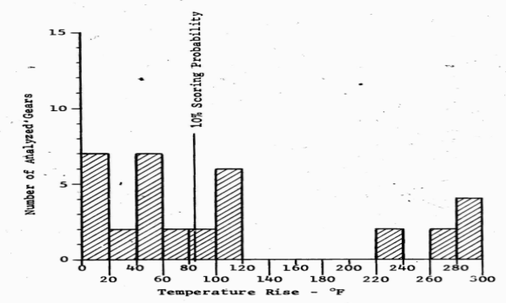

**Bearing failure:**

Bearings undergo primary failure twice as likely as gears and four times as likely as other components, such as cases, studs, oil jets, shafts, oil pumps, etc. The secondary failures which is often caused due to primary failures or corrosion show a similar relative failure rates.

As compared to gears, geometrical relationships in bearings, reveals the nature of increased secondary failure rate for bearings. The high geometrical osculation of the bearings encourages a greater degree of debris entrapment, while that of gears generally expels most debris. Thus high secondary failure rates favor bearings.

The primary failure rate ratio is significant, in that the ball failure rate is over ten times greater than the roller as shown in figure.

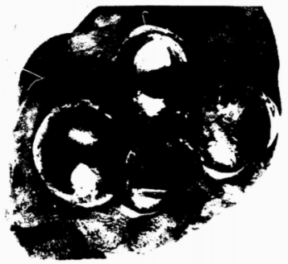

**DIAGRAMS:**  
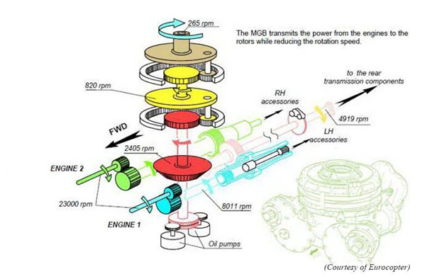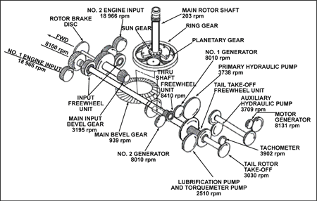

**REFERENCES:**

* <https://ntrs.nasa.gov/archive/nasa/casi.ntrs.nasa.gov/19920017312.pdf>
* <https://www.sciencedirect.com/science/article/pii/S0020740314001854>
* <https://www.enventure.com/blog/stress-concentration-factor-an-important-parameter-for-the-safety-of-any-component/>
* <https://www.sciencedirect.com/science/article/pii/S0895717711003967>
* <http://fac.ksu.edu.sa/sites/default/files/fatigue-chap9-rev-1-part4.pdf>
* <https://www.sciencedirect.com/science/article/pii/S1875389212000478>
* [https://smartech.gatech.edu/bitstream/handle/1853/7524/bellocchio\_andrew\_t\_200512\_mast.pd](https://smartech.gatech.edu/bitstream/handle/1853/7524/bellocchio_andrew_t_200512_mast.pdf)f
* <https://ntrs.nasa.gov/archive/nasa/casi.ntrs.nasa.gov/19800016828.pdf>
* <http://www.dtic.mil/dtic/tr/fulltext/u2/881610.pdf>
* [https://www.dora.dmu.ac.uk/bitstream/handle/2086/14755/Planetary%20bearing%20defect%20detection%20in%20a%20commercial%20helicopter%20main%20gearbox%20with%20vibration%20and%20acoustic%20emission.pdf?sequence=1&isAllowed=y](https://www.dora.dmu.ac.uk/bitstream/handle/2086/14755/Planetary bearing defect detection in a commercial helicopter main gearbox with vibration and acoustic emission.pdf?sequence=1&isAllowed=y)